Literacy – Summer 2 week 2 08.06.2020
*worksheets can be found below
1 | The topic for this term is summer! Can you think of some words that begin with ‘s’ and write these down?
2 | It is time to go outside! Have a look around your garden for some of the flowers in the worksheet below. If you find it, give it a tick. Maybe you can try researching these flowers on the internet or in books. See how many you can find!
3 | What is your favourite part about summer? Try and write down as many things as you can think of and be as detailed as you can. Don’t forget your finger spaces and full stops! Make sure to always read your work back to yourself. Grab yourself a piece of paper and a pencil and get started.
4 | Handwriting – It is time to practice some handwriting. This week, you will be practicing ‘q’ and ‘e’. Get yourself a plain sheet of paper and off you go. There is a worksheet below to help you get started. For an extra challenge, write some sentences using the words on the sheet.

2.
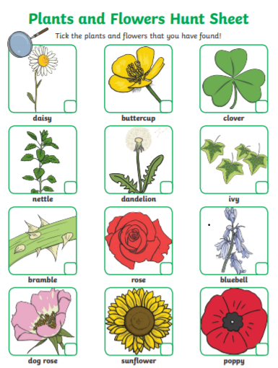

4. Handwriting
