Timetable week commencing 20/04/2020

Literacy: See grammar resources. This week will focus on sentence structure.
Write a paragraph about the picture provided using the following criteria:
- 1st person e.g. I can see, I can smell, I can sense
- Expanded noun phrases. E.g. My majestic, raven black wings….
- Use an example of each sentence structure. Eg. Simple, complex and compound sentences.

Reading: See readworks.org resources on the school website.

Maths: Follow the daily plans and complete the worksheet and self assess using the answers provided.
https://whiterosemaths.com/homelearning/year-5/
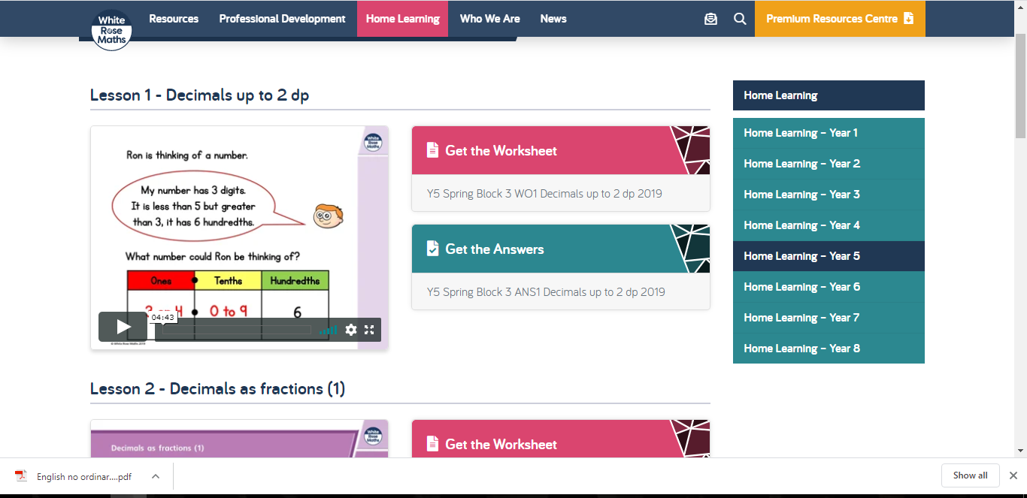

Topic:

- What can we find out about the Ancient Greeks?

Chdn to use Useful Websites and information books to research and make notes.
Information to include: The Olympics; Greek Democracy; Archimedes; Greek Philosophy; Maths: Euclidean Geometry, Pythagoras, Prime Numbers and The Sieve of Eratosthenes.

Useful websites for Ancient Greeks:
http://www.primaryhomeworkhelp.co.uk/Greece.html

Ducksters website:
https://www.ducksters.com/history/ancient_greek_government.php

BBC Bitesize:
https://www.bbc.com/bitesize/articles/z8q8wmn

Ancient Greece Mathematics:
https://thekidshouldseethis.com/post/79866139523

- Who were the Ancient Greeks?

Order the events on the timeline provided.

