**Marvellous Mummies**

Year 3 Summer Term 1

Homework Project

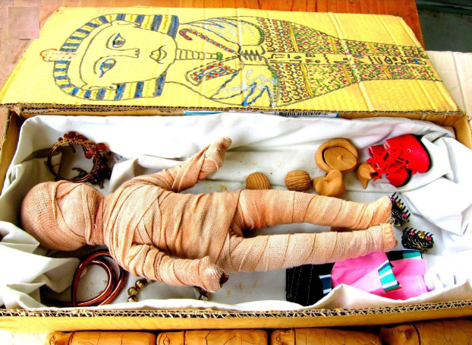

This half term, we’re learning all about Ancient Egypt!

Your project homework is to make a coffin for a mummy. Remember to decorate the coffin and put items inside it to show what their life was like. You can also write a biography about the mummy and tell us who he/she was!

Be creative and have fun with this project!

**Due date: Friday 24th May 2019**

*Here are some places that might help you with your project:*

* Google
* Youtube
* Pinterest
* Twinkl