**Downsell Primary school**

**Reception**

**Homework Set: Monday 14th December 2020**

**Homework due: Friday 15th January 2021**

[](https://www.bing.com/images/search?q=downsell+primary+logo&id=A22F15CE708E0B2449A1B1D94D3265912F90295D&FORM=IQFRBA)

**Resources I might need are:**

* **Scissors**
* **Card**
* **Paper**
* **Crayons/ Colour**
* **Paint**
* **Recycled material**
* **Glue**

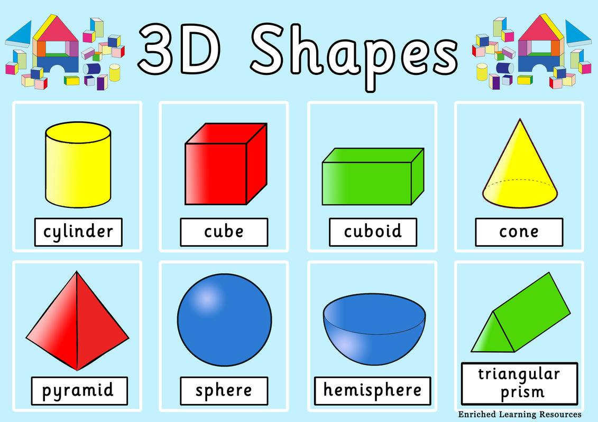

**Can you name and describe these shapes?**

**Why do we need 3D shapes?**

Create and build your own wild thing using recycled materials (boxes, tubes, plastic bottles, etc).

See the pictures below for examples.

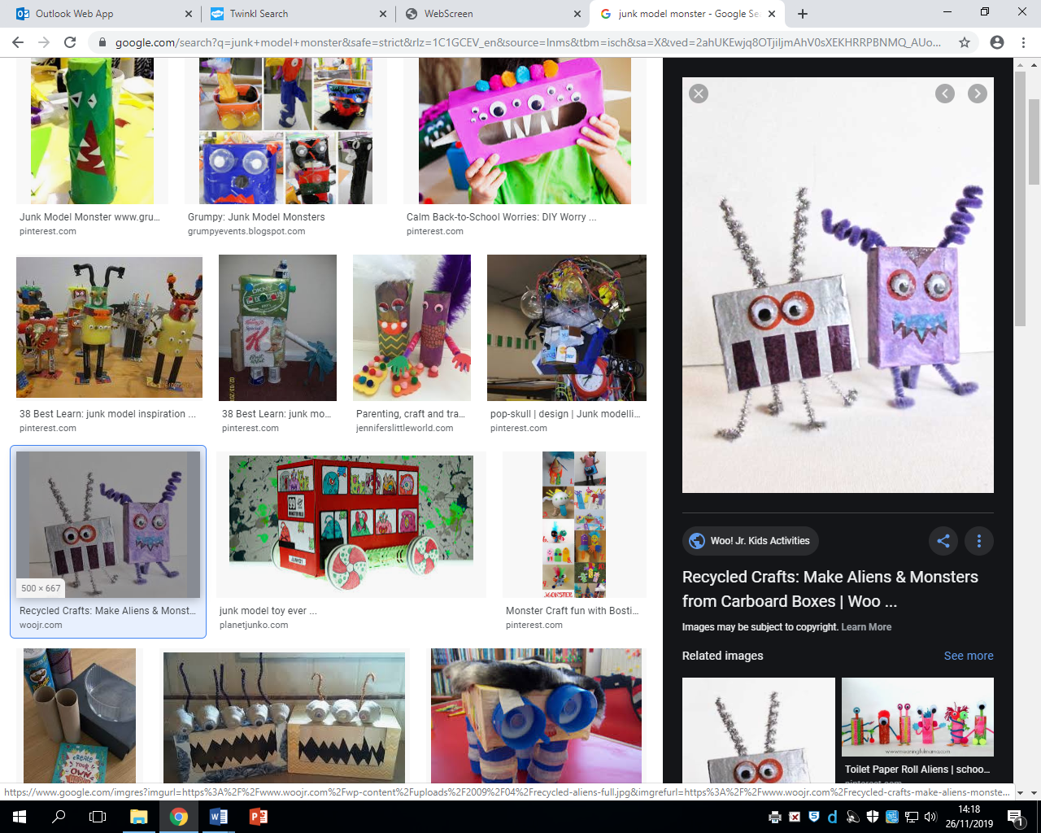

**Skills I may use are:**

* **Cutting**
* **Sticking**
* **Language development**
* **Fine motor control**

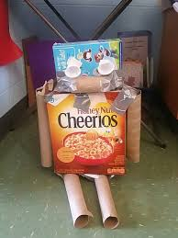

**Writing**

Design and label a plan of your model.