Year 3 Autumn Term 2

Homework Project

**Super Stonehenge**

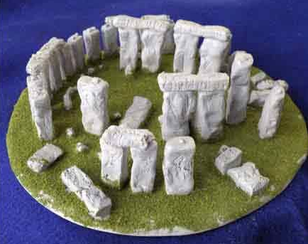

*Here are some places that might help you with your project:*

* <https://www.twinkl.co.uk/resource/t-t-25538-3d-stonehenge-paper-model-printable-activity>
* <https://www.pinterest.com/pin/557813103818506320/>
* <https://www.firstpalette.com/Craft_themes/People/miniaturestonehenge/miniaturestonehenge.html>

In Geography, we’re learning all about Stonehenge.

Your project is to make a 3D Stonehenge.

Be creative! We look forward to seeing your super Stonehenge!

**Due date: Friday 6th December 2019**