Year 3 Autumn Term 1

Homework Project

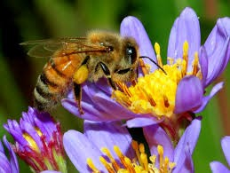

**Busy bees**

Here are some ideas:

* Draw a picture of a bee and label it
* Make a 3D model of a bee
* Either draw or make flowers that attract bees
* Make a fact file about bees
* Make a fact file about the flowers that attract bees
* Compile interesting mathematical facts about bees

…Or something of your choice related to bees

*Some websites to help you:*

<https://pestworldforkids.org/pest-guide/bees/>

<https://www.dkfindout.com/uk/search/bees/>

<https://honeybeesuite.com/are-bees-insects-or-animals/>

<https://www.natgeokids.com/uk/discover/animals/insects/honey-bees/>

<http://www.bbc.co.uk/guides/zg4dwmn>

This half term in Science we are learning about plants and photosynthesis.

Bees are always busy at work and we would like to create a display about bees.

Variety would bee amazing!

**Due date: Friday 18th October 2019**