Downsell’s Special Menu
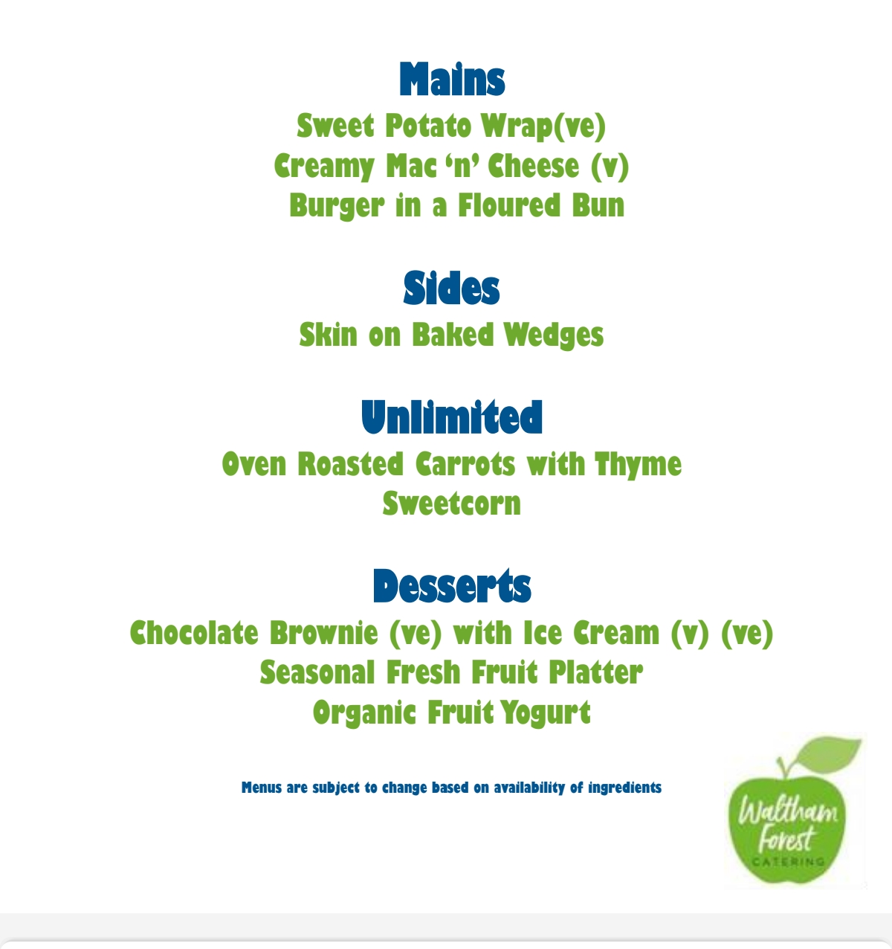
Thursday 5th October 2023

