Phonics – Summer 2 Week 2 – 08.06.2020
*All worksheets can be found below.
Practice your sounds daily – set 1, 2 and 3 sounds
https://www.oxfordowl.co.uk/for-home/reading-owl/find-a-book/read-write-inc-phonics--1/phonics-pure-sounds-video
1 | ‘ea’ work sheet – practice reading the ‘ea’. When reading one of your books, can you spot some words that have the ‘ea’ sound?
2 | As yesterday  Write some sentences using these words – tea, bean, read
3 | ‘oi’ worksheet – practice reading the ‘oi’. Look around your home. How many words can you find with the ‘oi’ sound around your house?
4 | As yesterday  Write some sentences using these words – coin, join soil
*Remember to read a book each day - either a book that you have at home or one of the e-books online. https://www.oxfordowl.co.uk/for-home/find-a-book/library-page/

Have a go at these green words!
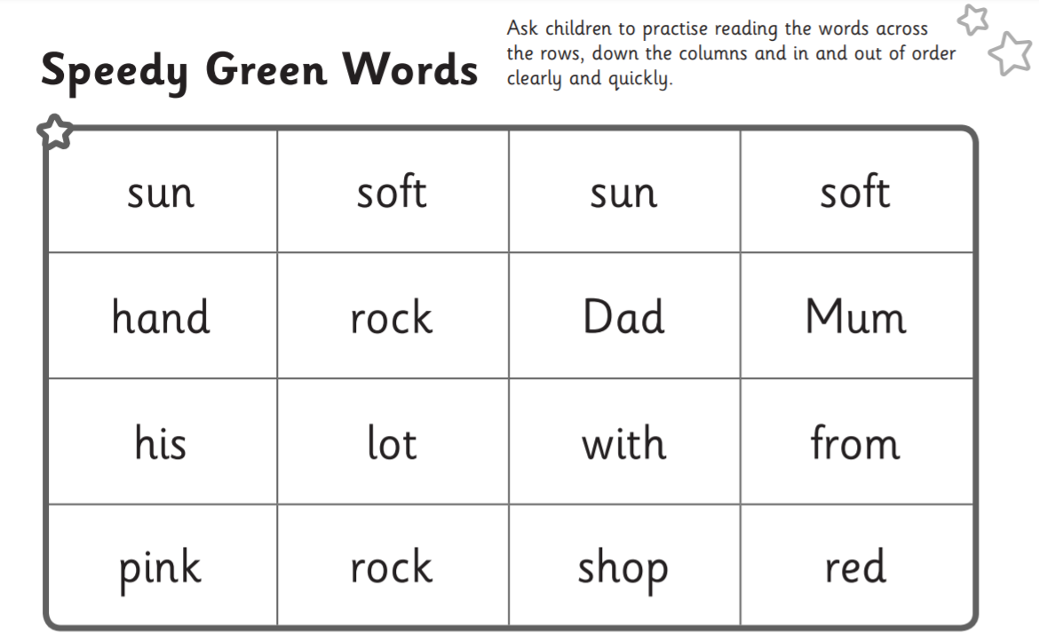

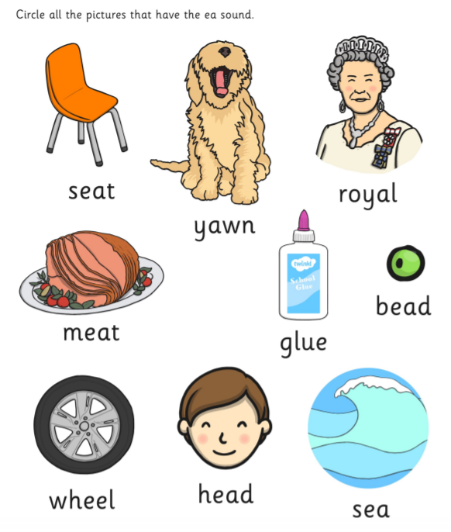
- ea worksheet

3.
Oi worksheet
