Maths – Summer 2 week 3 – Counting in 2s 15.06.2020
1 | Starter – Re-cap time from last week. Can we quickly draw a clock face and use some pencils to make 2 o’ clock? 4 o’ clock? 6 o’clock? 8 o’clock? 10 o’ clock? 12 o’ clock?  Main – This week, we are looking at counting in 2s! Parents – we have not learnt about this yet, so please be patient and make this week as fun as possible!  Here are some fun videos for you to watch with your child at home.  https://www.youtube.com/watch?v=GvTcpfSnOMQ  https://www.youtube.com/watch?v=JyCr0IgbYcI  https://www.youtube.com/watch?v=eTCcqQxT5Gk
2 | Starter – Have a look at your favourite counting in 2s video (videos above) and sing along to it 2 times.  Main – Take a look/walk around your house. We’re going to find pairs of objects! Can you find a pair of shoes? Socks? What else can you find that comes in 2s?
3 | Starter – As yesterday  Main – Today we are going to have a go at some work, there is a counting in 2s number below to help you. And of course, you can use your YouTube songs as well.
4 | Starter – As yesterday  Main - Number formation – Look at the worksheet below. Practice writing out your numbers using your best writing!
Key vocabulary – 2, 4, 6, 8, 10, 12, 14, 16, 18, 20

3.

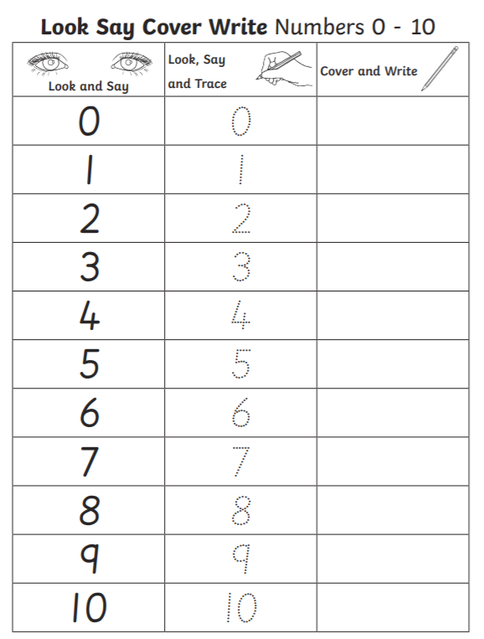
4.

