Phonics – week 3 – 06.04.2020
Phonics Daily
Practice your sounds daily – see previous weeks for web pages.
Recap the sound: ‘ay’ sound. Monday and Tuesday
display, stray, gay, sway,
Recap the sound: ‘ee’. Wednesday and Friday
seed, weed, cheek, bleed, feel been, deep, creep and breeze.
Over the week choose some of the words to write sentences. Can you think of or find any other words with the ‘ay’ or ‘ee’ sound?
Red words
were. where, there, their.
Practice reading and writing these words every day.
Numerals 6, 7, 8, 9, 10 practice reading the words and match them to the correct numeral – make a puzzle.
Remember you can make up phonic games to practice your reading.
Find the words. Write the words on paper. Hide them. Can you find and read the words? Play bingo.
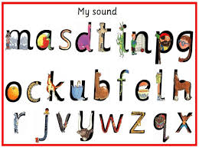
If you have created a great new game put it on our wab page so that the other children can enjoy your game too.

Read a book daily. It can be an e-book or a book of your choice. How does the story open? Who are the main characters? Can you describe the characters/setting? Can you predict/guess what is going to happen next in the story without peeping? Can you change the end of the story? Can you act out the story? Paint the characters/setting? Write a short description of the characters/setting?

