Tuesday – Introducing Algebra
Remember do the Inverse (Answer inverse sign Other number = unknown letter)
Apart from when the unknown number is subtracted so the operation stays the same.
Wednesday – Shape Algebra
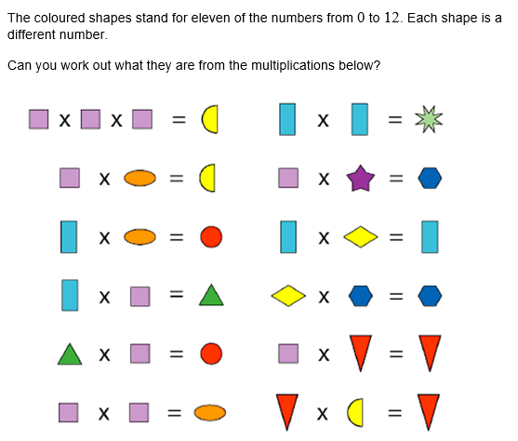

Thursday
Algebra Challenge Cards

Friday
Algebra Alphabet – Work out all the different number values for each letter (Hint: Use K to help you find A and N)

