Literacy – Summer 2 week 6 06.07.2020
*worksheets/pictures can be found below
1 | Did you have a good weekend? It is time to tell us what you did. Grab a sheet of paper and a pencil and tell us everything you enjoyed doing this weekend!
2 | The story for this week is The Snail and the whale!  https://www.youtube.com/watch?v=EmMnaSkeKqQ  We hope you enjoyed watching and listening to the story of The snail and the whale.  It is time to write some captions. Have a look at the caption worksheet down below. Remember to use your capital letters, finger spaces and full stops. Read your work back to yourself too!
3 | Think about the setting in The snail and the whale story. Where did the story take place? Use all your special describing words that you have learnt to describe the setting in the story. Remember to draw a picture of the setting once you have finished writing about it!  Setting picture can be found below
4 | Think about your favourite character from The snail and the whale story. Read it/watch it again if you want to! Can you describe this character using all the special describing words you have learnt? Grab a plain piece of paper and off you go! Remember to draw your character once you have finished writing about them.  Character pictures can be found below
5 | Now that you are familiar with the story, it is time to write about the different story elements.  Who were the characters?  What was the setting of the story?  Can you write about the beginning, middle and end of the story?  Use the story elements worksheet below to help you

2.
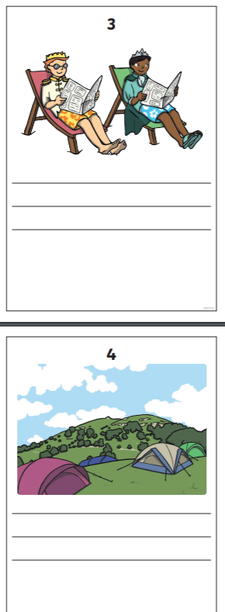
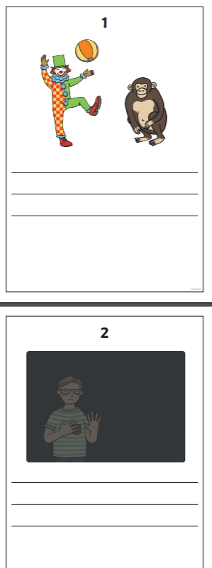

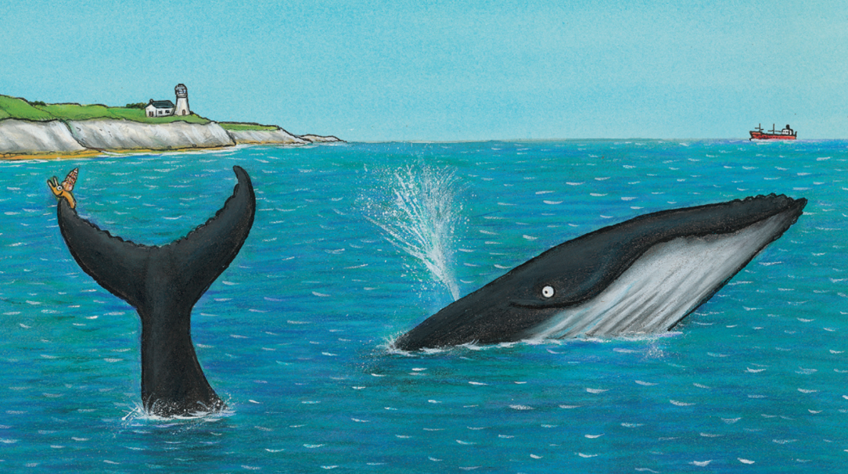
3.

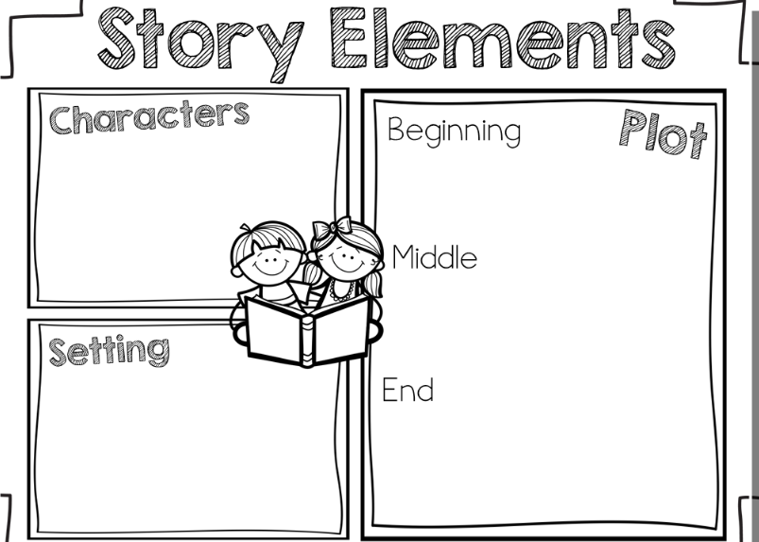
5.

