Tuesday 15th December
LI: To be able to explain imagery in poetry.

The door was shut, as doors should be,
Before you went to bed last night;
Yet Jack Frost has got in, you see,
And left your window silver white.
He must have waited till you slept;
And not a single word he spoke,
But pencilled o’er the panes and crept
Away again before you woke.
And now you cannot see the hills
Nor fields that stretch beyond the lane;
But there are fairer things than these
His fingers traced on every pane.
Rocks and castles towering high;
Hills and dales, and streams and fields;
And knights in armour riding by,
With nodding plumes and shining shields.
And here are little boats, and there
Big ships with sails spread to the breeze;
And yonder, palm trees waving fair
On islands set in silver seas,
And butterflies with gauzy wings;
And herds of cows and flocks of sheep;
And fruit and flowers and all the things
You see when you are sound asleep.
For, creeping softly underneath
The door when all the lights are out,
Jack Frost takes every breath you breathe,
And knows the things you think about.

He paints them on the window-pane
In fairy lines with frozen steam;
And when you wake you see again
The lovely things you saw in dream.
Task 1:
Answer Questions:

1.What does the word 'pencilled' mean in this context?
2.In the first verse, who is being addressed?
3.Why can you not see the fields?
4.What does the word 'yet' in verse one tell us about Jack Frost?
5.What is the word 'nodding' used to describe the plumes?
6.What does the word 'gauzy' tell you about the butterfly wings?
7.What season is suggested in verse six? Find and copy two phrases as evidence.
8.How do the things the person dreams of contrast with their current situation?
9.How does the mood change in the last two verses?

Task 2:
Write a winter poem
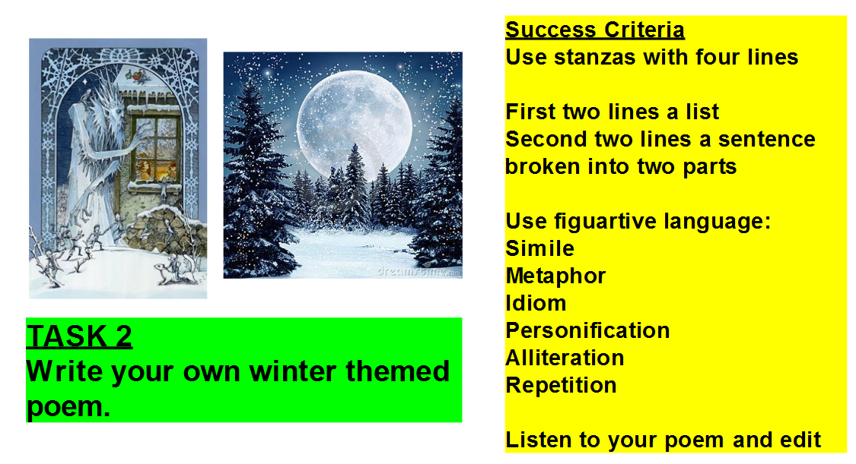

Wednesday 16th December
LI: To research and plan a non-chronological report.
Research an animal of your choice to write a non-chronological report about.

Make notes on the following subheadings:
Appearance
Habitat
Diet
Behaviour

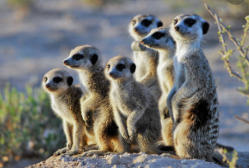
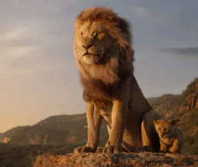
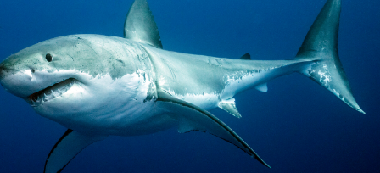
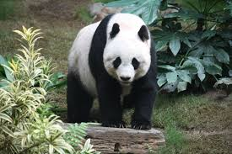

Thursday 17th December
LI: To write a non-chronological report.
Write a non-chrological report about your chosen animal. This can be word processed or hand written.
Subheadings to Include:
Introduction
Appearance
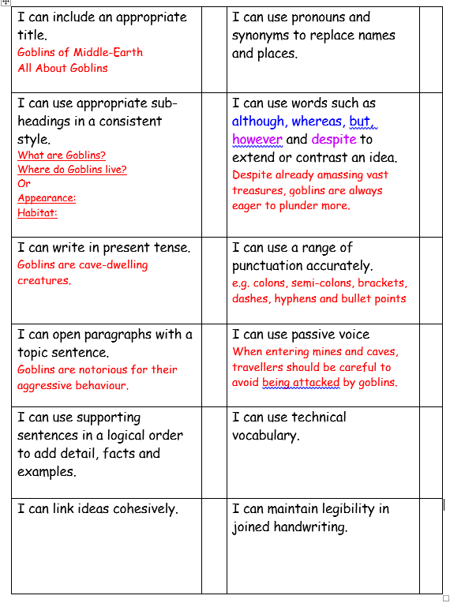
Habitat
Diet
Behaviour
Conclusion

