Downsell Primary School
Year 4 Newsletter-Spring Term
Dear Parents/Carers,
Welcome to the year 4 Newsletter for the Spring term. We hope your children had an enjoyable first term. We are looking forward to an exciting and productive time together. Here are some of the things to look out for:
Trips
The children will be going to visit the Museum of London as part of their topic this term for History. (How Romans Changed Britain).
P.E and P.E Kit
PE takes place every Thursday. Please make sure your child has blue shorts, PE shoes and a white T shirt. Do add their name to the inside labels so we do not lose garments during changing.
Topics This Term
Below is a summary of the topics being studied this half – term.
We will be studying:
Literacy: Stories from other cultures and Non- Chronological Reports.
Numeracy: Number and place value, written addition and subtraction, problem solving and reasoning, mental multiplication and division, properties of Shapes – 2D and algebra.
History : How Romans Changed Britain.
Art : Lightning Up.
. Music: Exploring Orchestra.
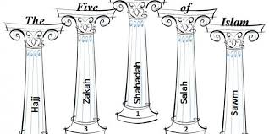 Religious Education: The Five Pillars of Islam.
Science: Electricity .

ICT: We are Toy Designers.

Homework
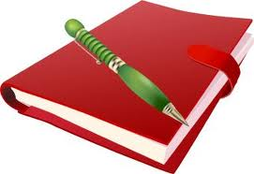
Homework is sent on Friday to be returned by the following Wednesday. This is based on the lessons the children have been working on during the week. If you need advice on helping your child with their homework please contact your teacher.
Spellings will be set as the children learn specific spelling patterns, which need to be consolidated and practised. Reading books are changed weekly. You can write comments in their reading diaries concerning your child’s reading progress at home. Your child is also encouraged to comment on the book they are reading.
Raining
Collecting Children when it rains.
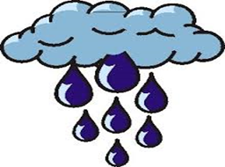
Class UAE from Class China
Class Pakistan from Class South Africa
Class France from Class Spain
Mr Hussain Ms Tehseen Mr Cooke
UAE Pakistan France

