Timetable week commencing 4/05/2020

Literacy: Read the newpaper article and create an up to date version of it .
Remember to include all the features of a newspaper report.

Features:
Headline
Orientation (who what when why where)
Date
By line (newspeporter)
Formal language (vocabulary)
Picture including caption
Eye witness report /opinion
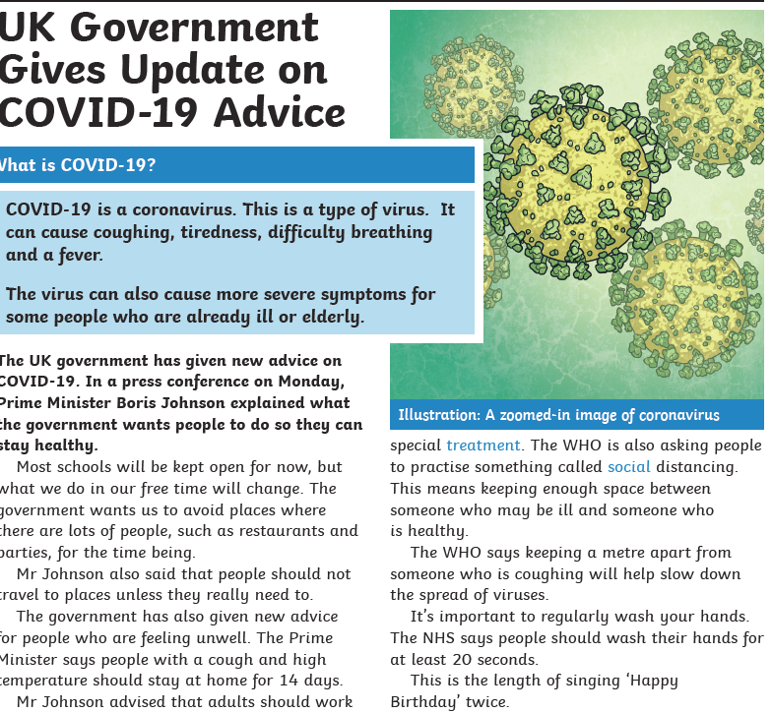

Grammar: Time Conjunctions
Create your own sentences using the time conjunctions.
See attached resources.

Reading: See readworks.org resources on the school website.

Maths: Follow the daily plans and complete the worksheet and self assess using the answers provided.
https://whiterosemaths.com/homelearning/year-5/
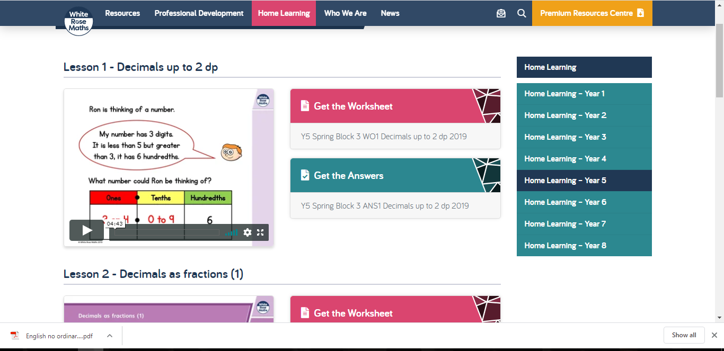

Topic:

Create a leaflet about Ancient Greece.
