Name:
Can I describe a picture?
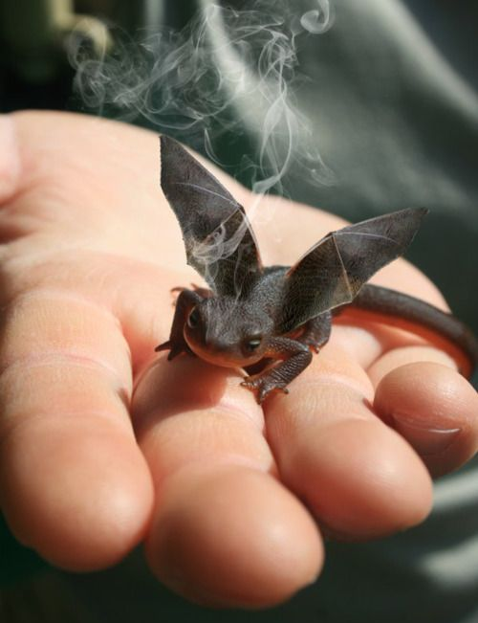 | baby dragon  lizard  blowing  smoke  cute  grey  black  bat wings  tail  hand  fingers  tiny  eyes  horns  feet  claws

 | 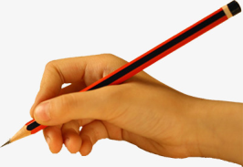 | ABC |  |  | 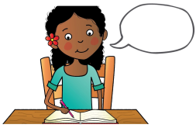
say the sentence | baby bird | capital letters | finger spaces | full stops | read your writing

