Talk for Writing – week 6 27.04.2020
Monday | Story Box  Find a shoe box. Add 2-3 characters – 1 has to be bad. You can draw them our use some of your toys.  Draw a picture of a setting or print one off.  Now you and your family use it to tell a story.  How does your story open?  What happens at the beginning, the middle and the end of the story?  Don’t forget to describe your characters/setting. What is the problem?  How are the characters feeling?  How is the problem solved?
Tuesday | Retell your story - using your story box  Use expressive voices
Wednesday | Act out your story – how do the characters move?  Show how they are feeling.  Write description of the character.  What do they look like?  Write 2 sentences or more if you have lots of brilliant describing words.
Thursday | Act out your story  Write description of the setting.  What can they see, hear, feel, colour, size?  Write 2 sentences or more if you have lots of brilliant describing words.
Friday | Act out your story  Story Map - Draw a story map of your story  Now use your story map to retell your story

You will need some characters
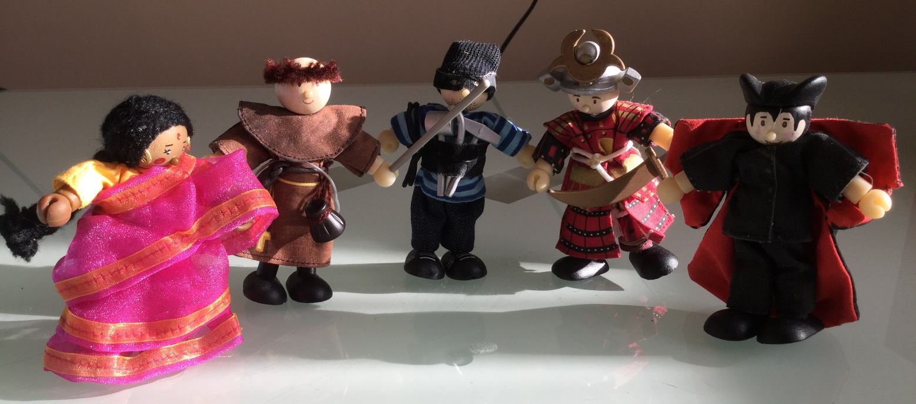
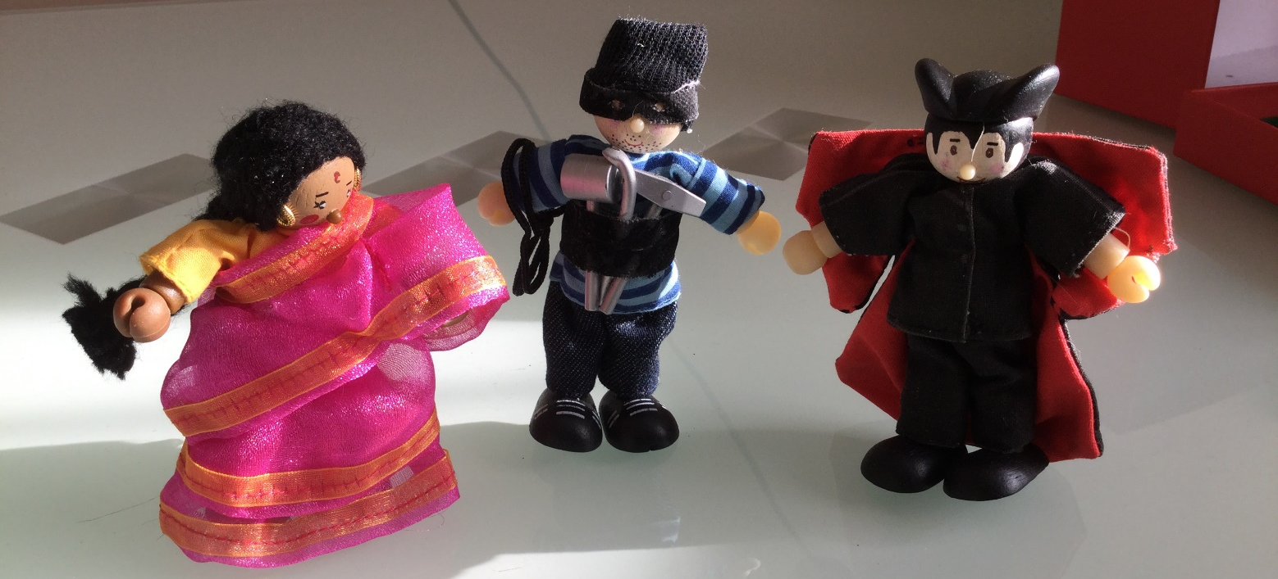

Create a setting
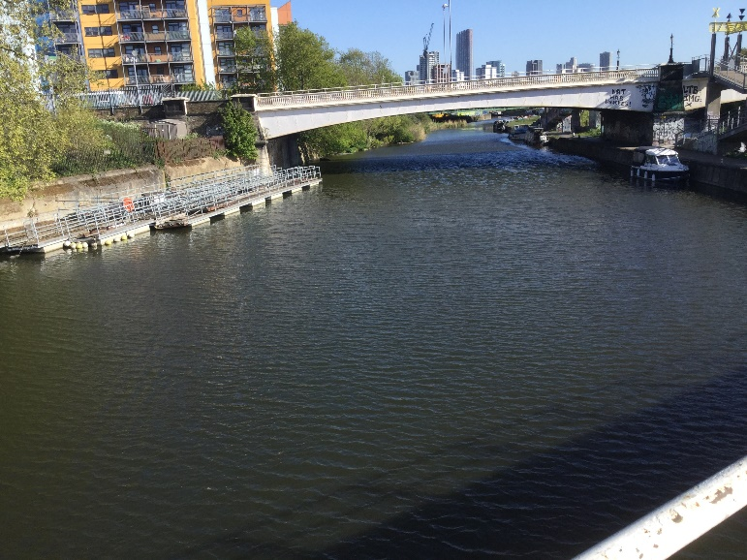
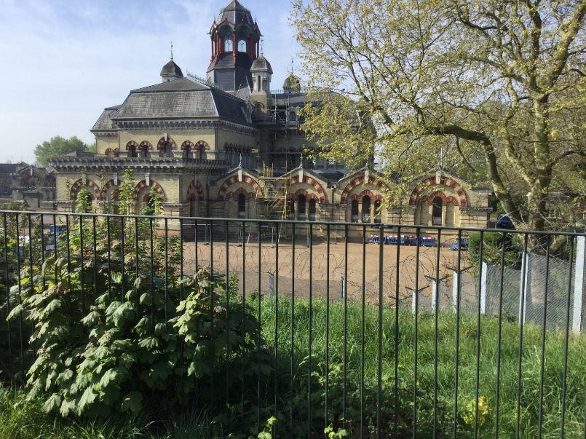
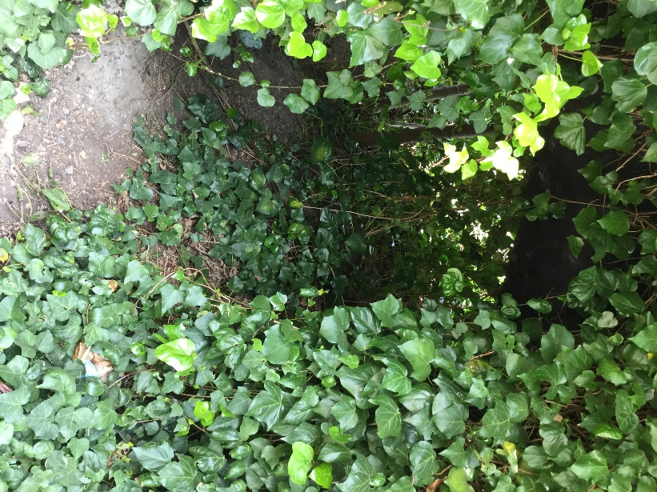

What can you see, hear?

What is the problem?
An alien space ship as laned in the playground and has disguised it has a children’s slide.

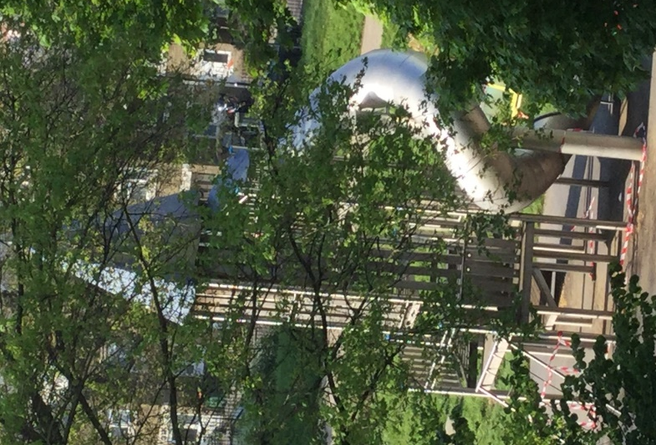

An enormous snail leaving rivers of silvery slime
You will need a shoe box and resources to make your setting. Remember you can draw pictures and cut them out.
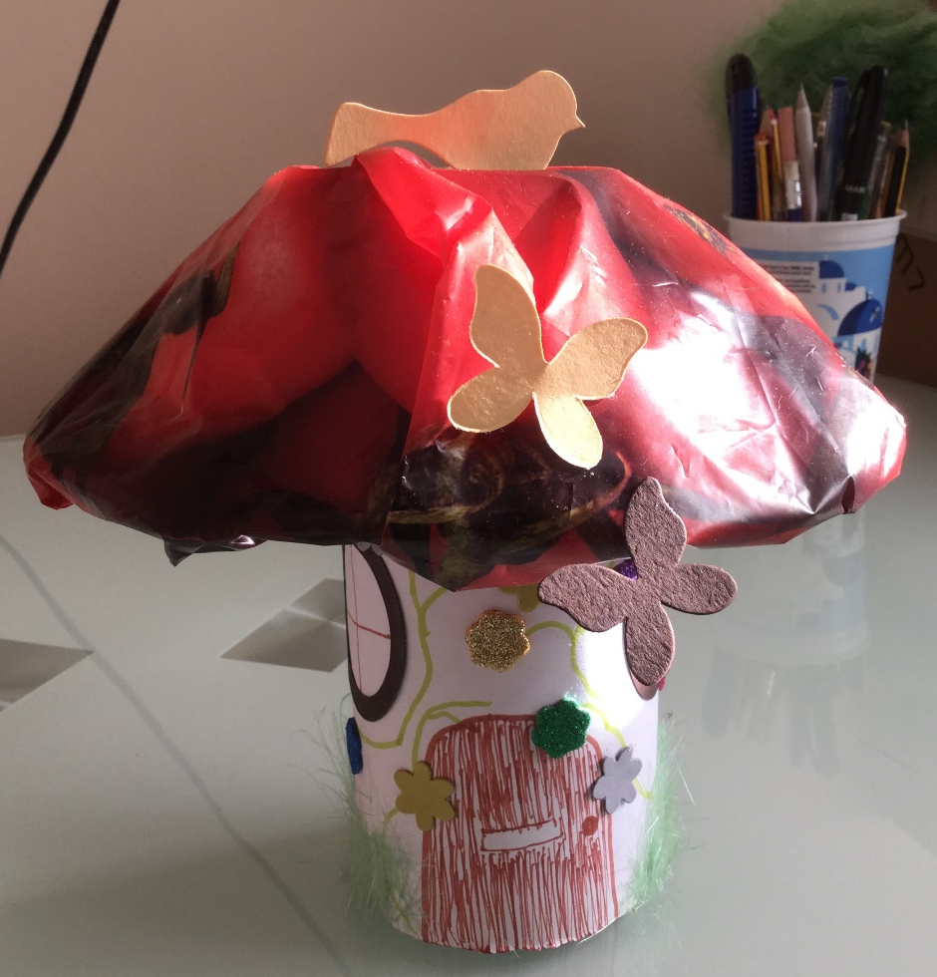
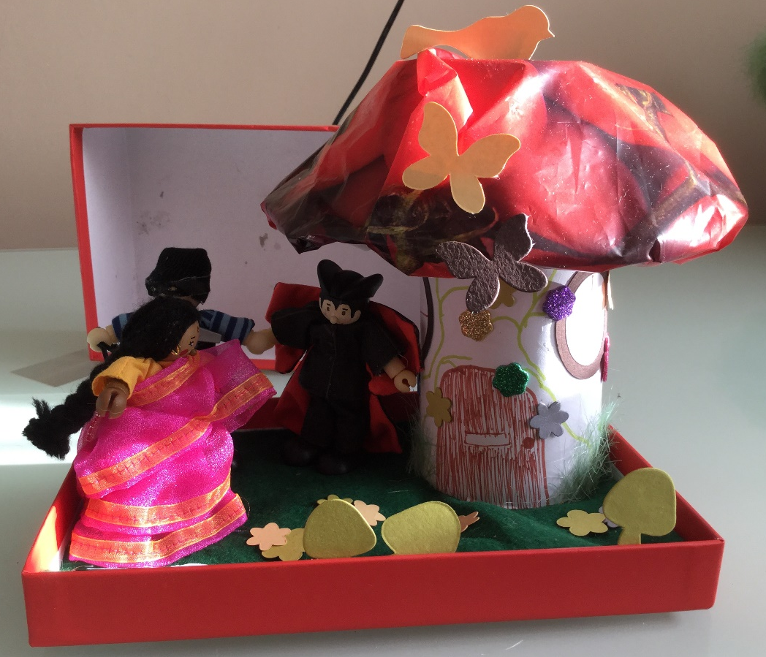

Don’t forget to put pictures of your work on our wab pages or tapestry.

