Year 3
Aut 2 Half Term Project Homework
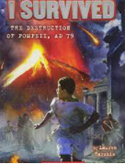
Next half term, we’re going to be reading the book called, ‘I Survived the Destruction of Pompeii, Ad 79’, written by Lauren Tarshis.
Your task is to make volcano models for our classrooms.
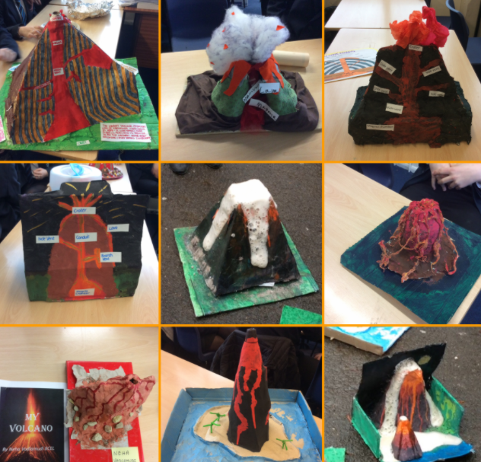
This project is an exciting opportunity for you to work with members of your family and get creative together.
Your completed projects are due on 13th January 2023.
We thank you in advance for your support and we look forward to seeing your fantastic creations!
Year 3 Team

