Spelling  Penny Art Jar Far Car Star Bronze dark bark Start Park Arm Silver Boat Coat Road Goal Coach Gold High Night Fight Light Bright Night | Homework  English  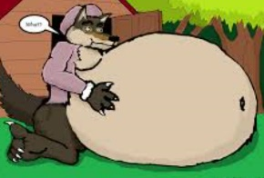  What could be in the big greedy wolf’s tummy? Can you think of some things big bad wolf ate for lunch? Or what is in this basket below?  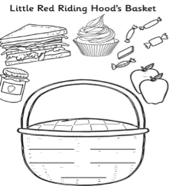 |  | Design a ship inside the flag like the ship next to the flag.  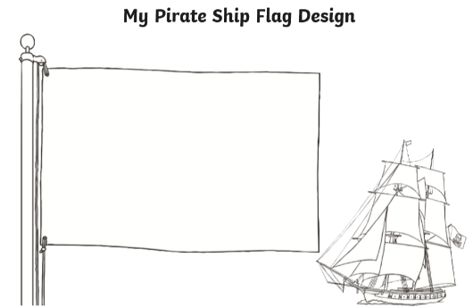  https://content.twinkl.co.uk/resource/12/37/t-t-5218-design-your-own-ship-flag-activity-sheet_ver_2.pdf?__token__=exp=1589560384~acl=%2Fresource%2F12%2F37%2Ft-t-5218-design-your-own-ship-flag-activity-sheet_ver_2.pdf%2A~hmac=d91d39278770f1aabb48ce8edfa22893b53df9b017cd914e1acd77ea75dcec7a  Geography  Oceans  https://www.youtube.com/watch?v=ThZj9TEMwgE&t=15s  Watch this video then answer the following questions  - How did Christopher Columbus travel the oceans?  - What did he do special?  - Who helped Christopher Columbus with all his trips?  - After the first trip to America, what goods did Columbus bring back with him to Spain?  What does Columbus say you receive after hard work?
(Please choose the right  Activity  To suit  Your child’s needs).  English Monday YBGO  Grammar Practice your punctuation.  Can you write the speech marks in the correct place? E.g. “Come downstairs and play with me” said Miss Ahmed.  - Can you come to play? Colin asked.  - I cannot find my tie anywhere, Mr Bentall grumbled.  - Be quick or we will miss the bus, called Laila.  - Your tea is on the table, Mrs Carter said to her son.  - The weather is horrible today, complained Mr Shah.  Red Group  Complete the blank spaces below:  - Ahmed said “ .”  - Helen said “ .”  - “ ” said Lucy.  - “ ” said James. | Tuesday YBGO  Comprehension  Use the words below to help you describe the characters and write in the correct boxes:  kind, mean, gentle, caring, evil, wicked, mean, cunning, wicked, sweet, sneaky, scary, friendly, cruel, helpful.  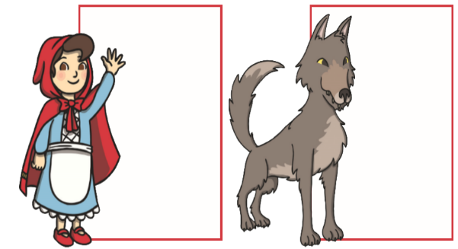  Red Group  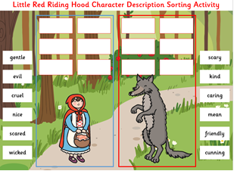 | Wednesday  Character Description 1  YBG  Use the following template to draw a picture and write a character description about Little Red Riding Hood.  https://content.twinkl.co.uk/resource/18/72/t-l-53913-character-profile-writing-template-_ver_2.pdf?__token__=exp=1589564123~acl=%2Fresource%2F18%2F72%2Ft-l-53913-character-profile-writing-template-_ver_2.pdf%2A~hmac=4f90911dbdaaf904d30c3242a042e41c30805b01c7b8a4ef82b168f5639d34a5  Under the sub heading character name and appearance describe how Red Riding Hood looks, e.g. Little red riding hood wears a dress.  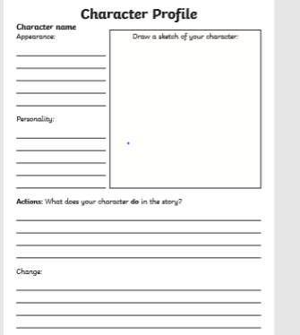  Red group  Use the key words below to write in the correct empty spaces.  - Little Red Riding Hood wears a .  - She looks .  - She visits her sick .  - Little Red Riding Hood picks some for her grandmother.  - She likes to carry her with her.  - She is .  Key words Kind, friendly, grandmother, basket, cape.  Can you think of any other ways to describe the character of the Little Red riding hood? |  | Thursday  Character Description 2  YGB  Use the following template to draw a picture and write a character description about the big bad wolf.  https://content.twinkl.co.uk/resource/18/72/t-l-53913-character-profile-writing-template-_ver_2.pdf?__token__=exp=1589564123~acl=%2Fresource%2F18%2F72%2Ft-l-53913-character-profile-writing-template-_ver_2.pdf%2A~hmac=4f90911dbdaaf904d30c3242a042e41c30805b01c7b8a4ef82b168f5639d34a5  Under the sub heading character name and appearance describe how the wolf looks and what kind of actions does he do. E.g. he is big.  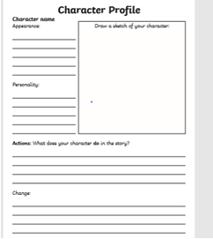  Red Group  Use the key words below to write in the correct empty spaces.  - The wolf is .  - He looks .  - He is .  - He tries to red riding hood.  - The wolf has .  - The wolf eats .  Key words: Scary, greedy, eat, trick, grandmother.  Can you think of any other ways to describe the character of the wolf?  Friday  YBG  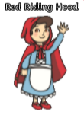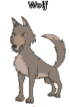  Look at the pictures of Red Riding Hood and the wolf. Describe what can you see, make sure you include in your writing:  - What the character looks like.  - How these characters act, speak and move.  What each of these characters think and feel.  - Use of interesting adjectives.  Red Group  Use the key words below to write simple sentences e.g. The wolf is brown.  Wolf: big, Hairy, sharp teeth, black nose, big eyes, pointy tail, long ears, clever, trick, greedy.  LRRH: red cape, frilly dress, red shoes, long hair, friendly, helpful, visits, basket.

