Year 3 Autumn Term 2 Week 1 and 2 Homework Project

**Incredible insects**

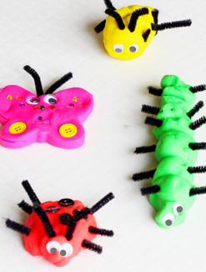

In English, we’re learning to write information texts about insects.

Your project is to make a 3D insect using different materials.

Be creative! We look forward to seeing your incredible insects!

**Due date: Friday 9th November 2018**

*Here are some places that might help you with your project:*

* Youtube
* Pinterest
* Iheartcraftythings
* Hobby craft blog
* Classroom magic blog
* Twinkl