**Maths – week 3 – 06.04.2020**

Daily – using a Number line

Write numerals 0-20 on A4 sheets of paper. Lay them out on the floor in the correct order to make a number line. Or use bottle tops.

Roll a dice or spin a number spinner. Stand on this number. Roll the dice again or the spinner. Walk forward or back, that number of spaces. What number have you landed on. Repeat a few times.

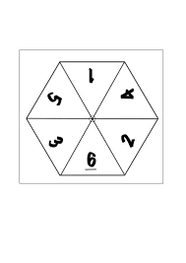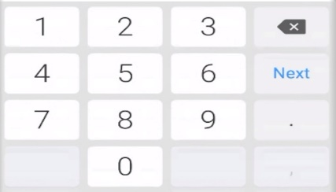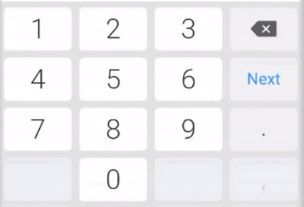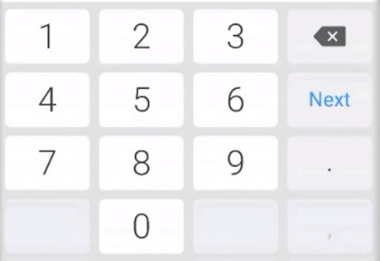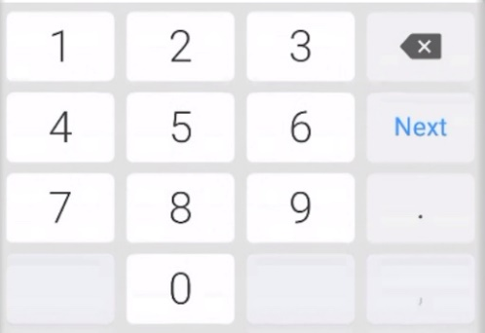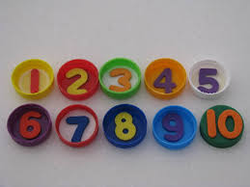

<http://www.hbschool.com/activity/numberline1_5_04/>

**Monday** – **Adding** - roll your dice twice to create number sentences. Use your number line to work out your answers. In what direction are you moving? What is happening to the numbers?

**Tuesday** – Draw your own number lines.

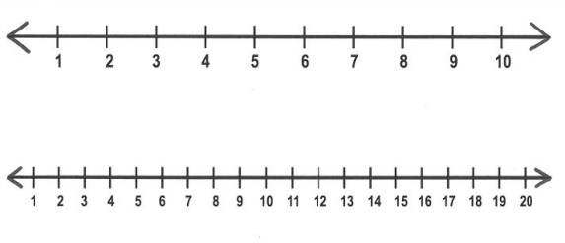

3 + 4 = ?

Create and write your own addition number sentences. Use your number line to show how you have worked out your answers. **Fancy a Challenge** - Can you add 3 small numbers?

**Wednesday** – **Taking away** – Lay out your number line. Have 2 piles of cards, one with numerals to 6, the other with numerals over 10. Pick 1 card from each pile. Create a take away number sentence. **Remember when taking away to start with the largest number**. Move along your number line to work out your answers. In what direction are you moving? What is happening to the numbers? Repeat a few times.

<http://www.hbschool.com/activity/count_back_numberline/>

**Thursday** – Draw your own number lines.

Create and write your own take away number sentences. Have 2 piles of cards, one with numerals to 6, the other with numerals over 10. Pick 1 card from each pile. Create a take away number sentence. Use your number line to show how you have worked out your answers. **Fancy a Challenge** - Can you take away 2 small numbers? 8 – 3 – 2 = ?

**Friday** – mix - Adding and taking away. Simple word problems.



Freddy the zebra has 2 stripes. His twin has 4 stripes.

How many stripes do they have altogether?



Tammy the hen had 3 chicks. Lilly the hen had 3 chicks.

How many chicks did do they have altogether?



Kelly the lion had 5 cubs. The next year she had 3 more cubs.

How many cubs did Kelly have in total?

There were 7 stars in space. An alien spaceship zapped 5 away!

How many stars were left?

**When working out word problem encourage your child to look for key words and number. Then write the number story. Can use a number line or objects to work out the answers.**

* total = adding
* altogether = adding
* left = take away
* away = take away