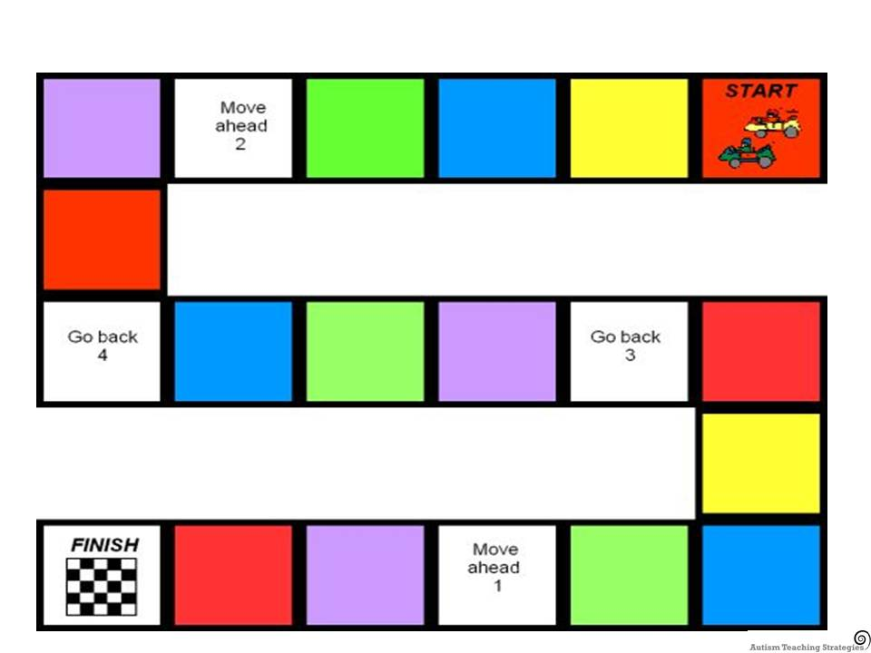

How to play: Take turns to roll the dice and move along the board, the number of spaces the dice shows. Say the number bond that makes 5. The first person to finish is the winner. You will need a dice and a counter for each player.

Making 5

5

2

4

3

1

5

0

1

3

5

2

0

4

2