Learning Today, Leading Tomorrow

PTA meeting
Date: Tuesday 14th November 2017 at 9.15am
Present: F, S, K and M
Apologies: Sa and MR

Idea | Action
Winter Wonderland | - 2 PTA stalls – 1 is jolly jar and the other is reindeer craft  - Jolly jar stall will need at least 2 people  - Reindeer stall will need resources – M will find out from Art/D&T Lead if there are resources that can be used  - PTA will purchase A3 brown card for the reindeer headbands  - Tupperware boxes for money handling  - F to finalise newsletter entry and send to Head to check  - S to check prizes for jolly jar winners – winner for each year group to be given something different priced from £5-£10  - PTA to reach out to external contacts to see if prizes can be donated – K to write letter for this – F has contact details given by previous chair
PTA bingo night in Spring | - F to enquire if SB can lead and organise
External contacts | - K to draft a letter to reach out to external contacts  - F to check with Head about acceptable methods of external contact (letter, telephone, in person)  - Possible contacts – cinema, theatre, Asda, Waitrose, Marcus James (contact them for Easter event), Haart estate agents, local florists
Vision | - 1line sentence to go on the school website and put on leaflets and flyers when giving information out about events  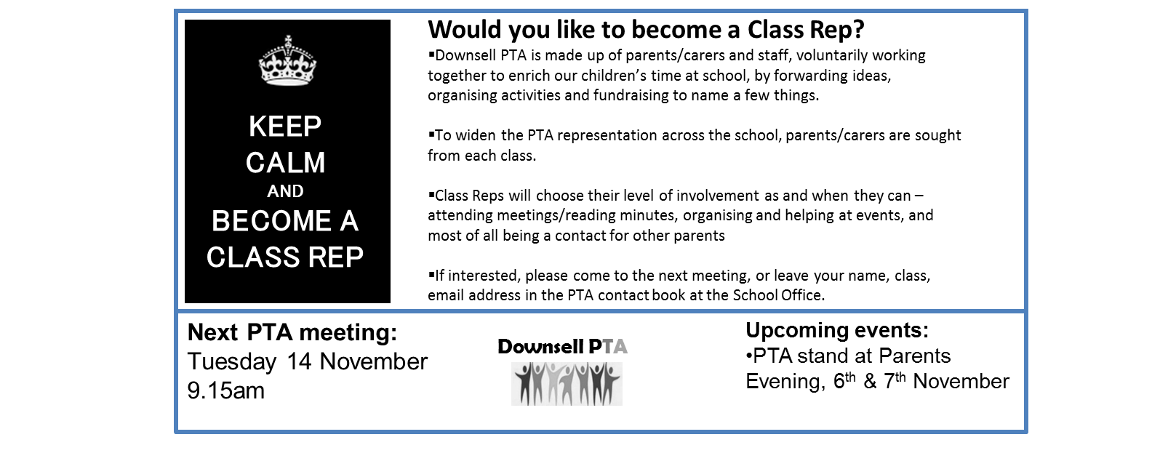
Targeting parents | - Target parents via newsletters and text messages which works effectively  - F to check with office about flyer that was given out last year for summer spectacular targeting parents to support  - PTA would like an entry in the parent handbook or give out a PTA flyer when a new child starts school  - PTA will organise a coffee afternoon to target parents unable to make morning meetings  - Parents Evening PTA stand -try for Spring term. Possibly give teachers PTA information leaflet to give out at Parents Evening.
Class reps | - Have a PTA stand in playground in early in Spring term- morning & afternoon  - F to put something on the newsletter nearer the date
PTA board | - PTA to ask the office for the key  - Display events and information on the board outside the school front office
PTA banner | - PTA to look into having a banner (similar to ones on school gates) to spread information about PTA  - F to check this with Head and ask SB if he has any printing contacts
Second hand uniform sale | - To start in Spring term
Protocol for idea approval | - Currently all PTA items discussed in meetings. When minutes sent for approval, any ideas raised and checked with Head in same email.  - To verify/agree with Head protocol going forward:  When Senior Staff Rep present at meeting, can approve items & forward remaining items for Head. When not present, should items be raised for Senior Staff Rep to approve, or raised with Head?
Agenda for next meeting  Tuesday 28th November 2017 | - Bring & prepare resources for the reindeer stall  - Check status of parent reps  - Book a date in the diary for the second hand uniform sale  - New Easter event idea – Bunny Ball (disco)

