Success Criteria
* I can brainstorm my character's physical features and personality.
* I can decide my character's actions within a situation.
* I can integrate action and description within sentences (specific vocabulary and phrases)

Task 1: Write a paragraph from the viewpoint of Wolf. Use the plan you made yesterday and the sentence structure.
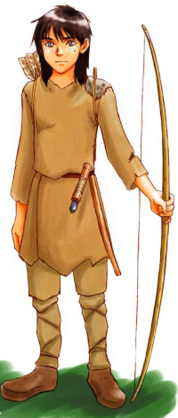
Task 1 sentence structure Wolf

Sentence with an -ing beginning

Dashes for dramatic affect

Relative clause sentence

Expanded noun phrase

Task 2: Write a second paragraph from the viewpoint of Torak.Use the plan you made yesterday and the sentence structure.
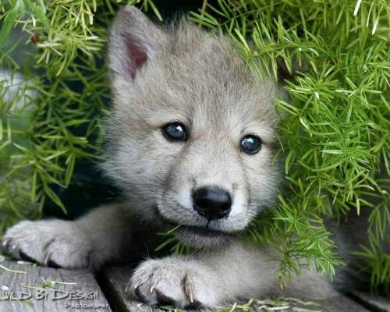
Task 2 sentence structure Torak

Brackets sentence

-ing beginning and a sentence starter

Relative clause

Semi-colon sentence

